# Netflix Content Insights Report

Introduction

In this project, I performed a comprehensive analysis of Netflix’s content dataset with the goal of uncovering key trends, user-focused patterns, and content distribution across time, genre, country, and format. The analysis was carried out using Python in Jupyter Notebook for data preparation and exploratory analysis, followed by Tableau for creating rich and interactive visualizations. The insights derived from this project can help in understanding Netflix's content strategy, audience preferences, and growth over time.

Tools Used and Their Purpose

## Jupyter Notebook (Python)

Jupyter Notebook served as the primary environment for data preprocessing and analysis. The following steps were carried out:

Data Cleaning:

* Removed or filled missing values in important columns such as Country, Rating, and Duration.
* Standardized date formats, split multi-country and multi-genre entries for better clarity.

Feature Engineering:

* Extracted the release year and the year the content was added to Netflix.
* Categorized durations into numeric minutes (for movies) and episode counts (for TV shows).
* Separated genres and created a multi-label structure to analyse genre frequency.

Exploratory Data Analysis (EDA):

Used libraries like pandas, matplotlib, and seaborn to analyze:

* The ratio of Movies vs. TV Shows.
* Ratings distribution across titles.
* Trends in content addition by year.
* Genre-wise and country-wise breakdown of titles.

Virtualization:

## Tableau

Tableau was used to build dynamic and easy-to-understand dashboards based on the cleaned Netflix dataset. The visuals helped transform raw numbers into actionable insights. The following charts and dashboards were created:

Genre Analysis:

* A bar chart showing the most common genres for both Movies and TV Shows.
* Insights into hybrid genres like “International TV Shows” or “Children & Family Movies.”

Ratings Distribution:

* Pie and bar charts showing how Netflix titles are distributed across various maturity ratings like TV-MA, PG-13, G, etc.

Titles Added per Year:

* A timeline chart showing how many new titles were added to the platform each year.
* Clear indication of a rapid rise in new content around 2016 to 2020.

Recency Histogram:

* Showed how recent the additions were, revealing that Netflix consistently adds newer content.

Geographic Distribution (Map View):

* A world map that visualizes the origin of content across different countries.  
  Helped highlight international collaboration and content diversity.

Key Insights

**Content Type Distribution:**- The dataset revealed that Movies make up the majority of Netflix's content, with TV Shows being a smaller but significant portion.  
- This indicates Netflix’s preference for producing or acquiring movie content, likely due to shorter production timelines and broader appeal.

**Genre Trends:**  
- Top Genres include:  
 - Dramas, Documentaries, and Comedies for both content types.  
 - International TV Shows and TV Dramas for series-type content.  
- Netflix heavily features global and regional content, aligning with its strategy to cater to international markets.

**Audience Ratings Analysis:**  
- The majority of content is rated TV-MA (for mature audiences), followed by TV-14 and PG-13, suggesting that Netflix primarily targets a teen and adult audience.  
- Only a small portion of the content is child-friendly (e.g., G or PG-rated), although this may vary across regions.

**Temporal Trends (Year Added):**- There was a major spike in titles added post-2016, with the peak in 2019–2020.  
- This aligns with Netflix’s global expansion and increasing investment in original content during those years.

**Geographic Reach:**- The map visualization showed that content on Netflix comes from a wide range of countries, with a strong base in:  
 - United States  
 - India  
 - Argentina  
 - France  
 - South Korea  
- This emphasizes Netflix’s role in promoting international storytelling and regional language content.

**Recency of Content:**- Most titles were added within the past 5 years, indicating Netflix’s focus on keeping the platform updated with fresh content.  
- Older content is still available but in smaller proportions, likely due to licensing limitations or strategic removal.

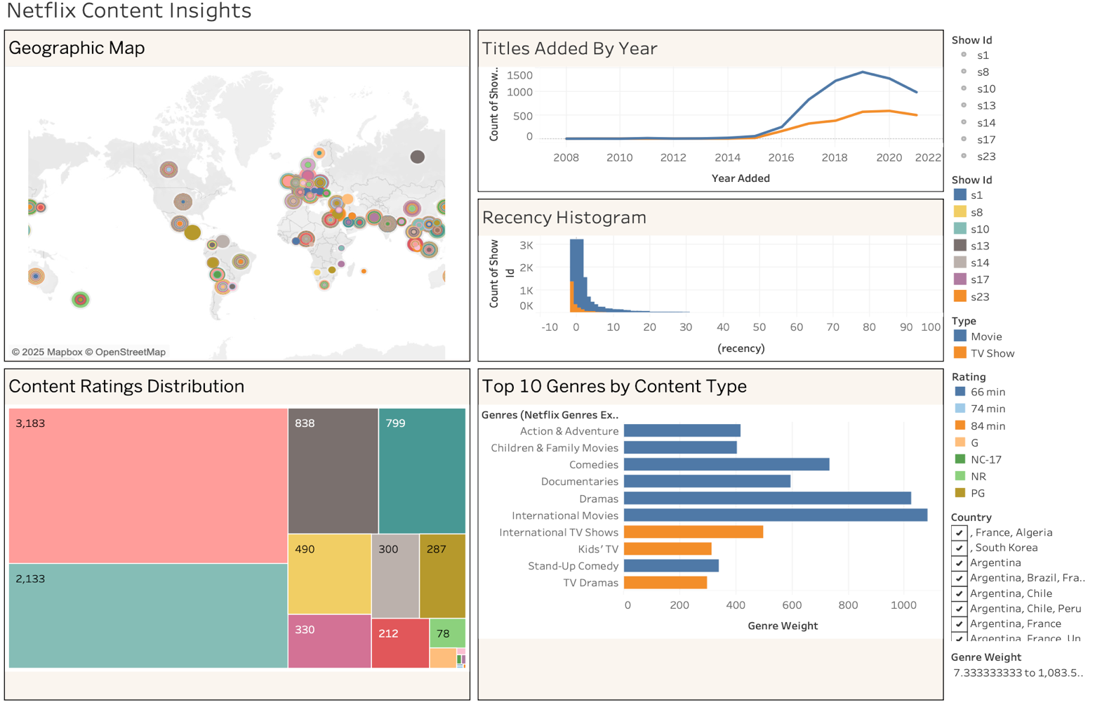

# **Conclusion**

By combining Python-based analysis with Tableau visualizations, this project successfully uncovered key patterns in Netflix's content strategy. From content type preferences to global content sourcing and evolving genre trends, the insights derived offer a clear picture of how Netflix curates its library to appeal to a global, diverse audience. This kind of analysis can be invaluable for content planners, marketers, and data-driven decision-makers within the streaming industry